Assignment01
- Caculate the mean, median, and mode for each of the following populations of numbers:
  - 17, 23, 19, 20 ,25, 18, 22, 15, 21, 20
  - 505, 497, 501, 500, 507, 510, 501

- Lauren is a college sophomore majoring in business. This semester Lauren is taking courses in accounting, economics, management information systems, public speaking, and statistic. The sizes of these classes are, respectively, 350, 45, 35, 25, and 40. Find the mean and the median of the class sizes. What is a better measure of Lauren’s “typical class size”- the mean or the median?

- Table 3.4 gives the percentage of homes sold during the fourth quarter of 2006 that a median income household could afford to purchase at the prevailing mortgage interest rate for six Texas metropolitan areas. The data were compiled by the National Association of Home Builders. Calculate the range, variance, and standard deviation of this population of affordability percentages.
Table 3.4
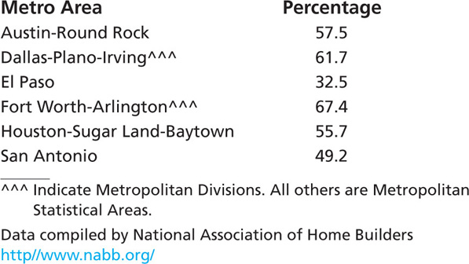

- THE BANK CUSTOMER WAITING TIME CASE
The mean and the standard deviation of the sample of 100 bank customer waiting times are c=5.46 and s=2.475.
  - What does the histogram in Figure 2.16 say about whether the Empirical Rule should be used to describe the bank customer waiting times?

  - Use the Empirical Rule to calculate estimates of tolerance intervals containing 68.26 percent, 95.44 percent, and 99.73 percent of all possible bank customer waiting times.

  - Does the estimate of a tolerance interval containing 68.26 percent of all waiting times provide evidence that at least two-thirds of all customers will have to wait less than eight minutes for service? Explain your answer.

  - How do the percentages of the 100 waiting times in Table 1.8 that actually fall into the intervals[s], [2s], [3s] compare to those given by the Empirical Rule? Do these comparisons indicate that the statistical inferences you made in parts b and c are reasonably valid ?
Figure 2.16
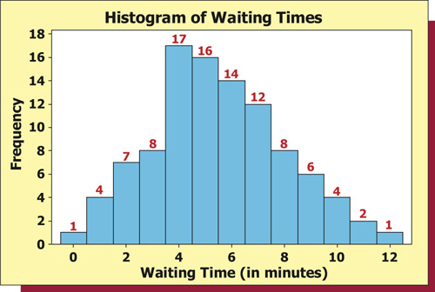

Table 1.8 Waiting Times (in Minutes) for the Bank Customer Waiting Time Case
